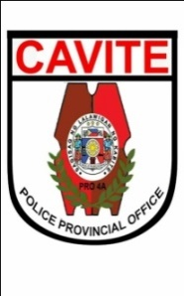Republic of the Philippines

NATIONAL POLICE COMMISSION

**PHILIPPINE NATIONAL POLICE, POLICE REGIONAL OFFICE CALABARZON  
CAVITE POLICE PROVINCIAL OFFICE**

**CARMONA MUNICIPAL POLICE STATION**

J.M. Loyola St., Brgy.Maduya, Carmona, Cavite

**MEMORANDUM**

FOR : Provincial Director

Cavite PPO

(Attn: C, PIDMU)

FROM : Acting Chief of Police

SUBJECT : **Submission of Actual Number of PUPCs and Total Number of**

**Days under PNP Custody**

DATE : June 1, 2022

1. Reference: Memorandum from C, FD dated January 02, 2022 with subject same as above.
2. This pertains to the continues programming of the Subsistence Allowance for Persons Under PNP Custody (PUPCs) based on the Actual Number of Days under PNP Custody.
3. In connection with the above reference, submitted herewith are the data required for the month of May 2022 to wit:

|  |  |  |
| --- | --- | --- |
| **Period Covered (Monthly)** | **Actual Number of PUPCs** | **Total Number of Days under PNP Custody** |
| May 2022 | 55 | 1044 |

1. For information.

**JOSEPH C CARLIT**

Police Major